A Cat in a Tree Problem Solving Activity

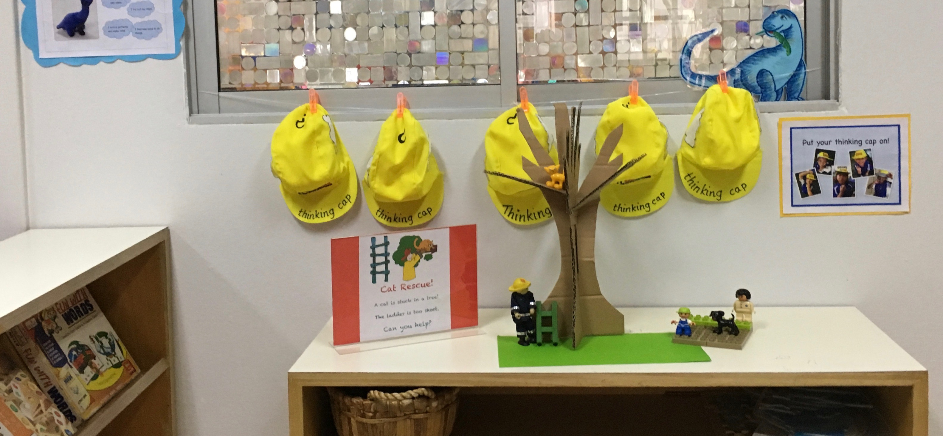
A cardboard tree and small world cat, firefighter and ladder.

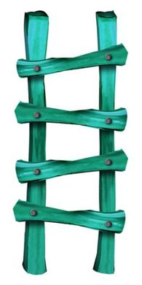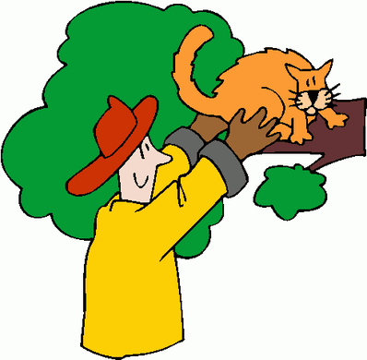
Cat Rescue!
A cat is stuck in a tree!
The ladder is too short. Can you help?

The problem
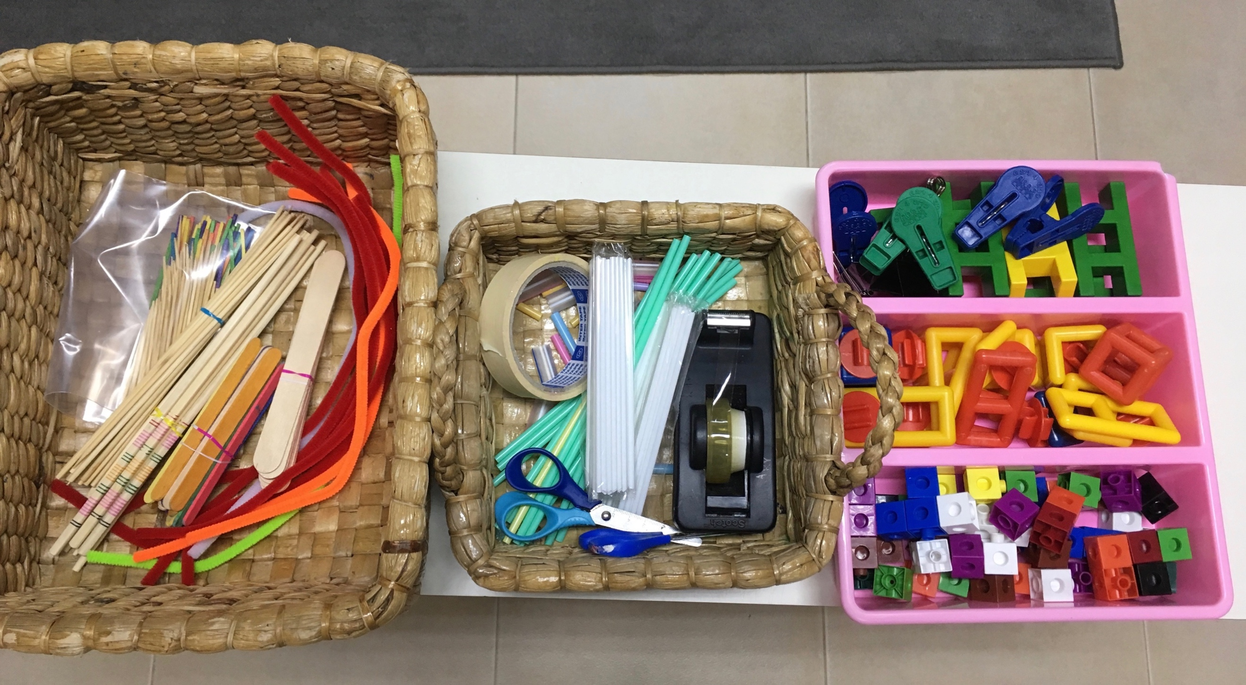
A selection of materials: craft and construction

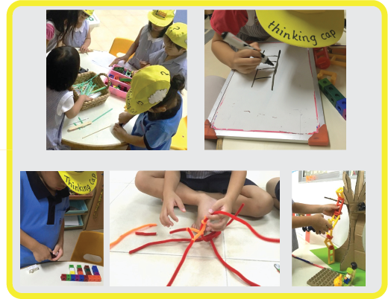
Lots of group discussion about what would be best to make a ladder or extend the short one. White boards or paper encourage planning. Next testing the design, is it tall enough? Strong enough? How could it be improved?

